# Experiment No -1

Title: Create a website using HTML and CSS code to design webpages .

# Date:-

**……………………………………………………………………………………..**

(Note:- on 1st page (title page) -- only write experiment details)

**Create a webpage using HTML and CSS code to design a web page as the layout displayed below.**

The top section will display the heading, ‘Tourist places’ in header. The section on the left has list of cities. The right hand side displays tourist places of any one of the city.

Use Inline style sheet in the top section to display background color for the text ‘Tourist places’. Use internal stylesheet for the left and right section with background color and font styles.

|  |  |
| --- | --- |
| **Tourist places** | |
| **City**   1. Pune 2. Banglore 3. Hyderabad 4. Delhi | **Tourist places in Pune**   * Shanivarwada * Kelkar Museum * Sinhgad fort |

**(Note-from 2nd page start Question-answers) Q1. Which are the form controls of HTML5?** Ans: Forms in HTML is used to accept user input.

Form controls are used to collect different kinds of user inputs, such as contact details like name, address, single or multiple options from group of options, as well as clearing and submitting data etc.

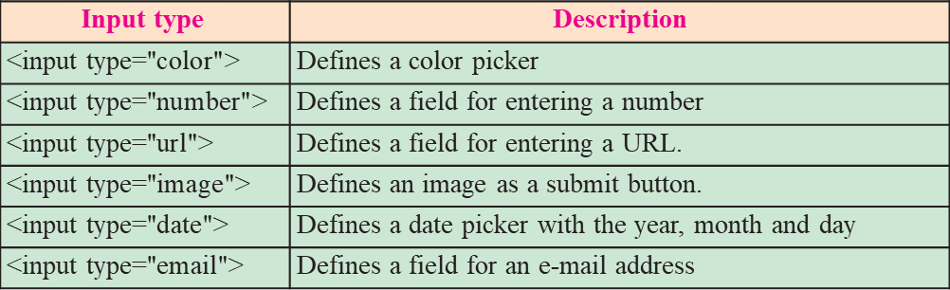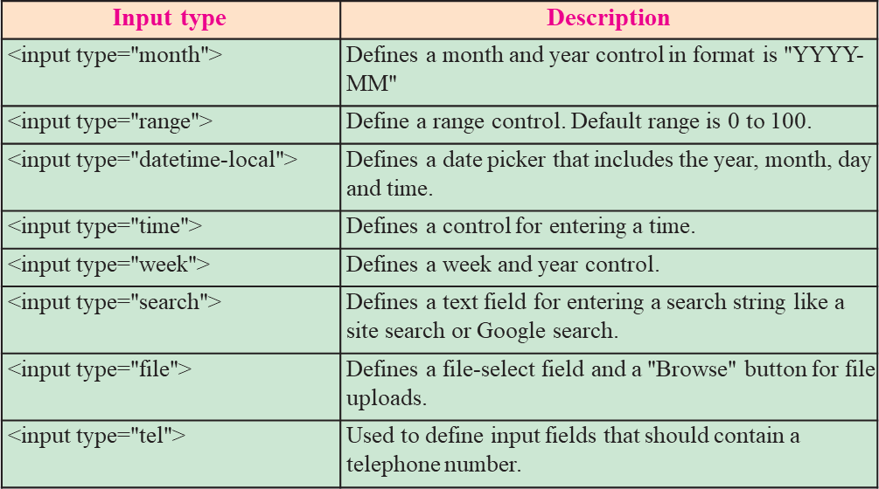

# Q2. Write short note on CSS ?

Ans:: CSS stands for Cascading Style Sheets.

CSS describes how HTML elements are to be displayed on screen, paper, or in other media

* A CSS rule set contains
  + a selector and a declaration block.

# CSS Syntax

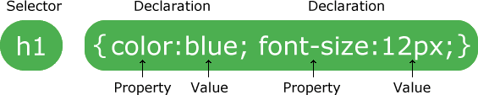

* selector points to the HTML element you want to style.
* declaration block contains one or more declarations separated by semicolons. Declaration blocks are surrounded by curly braces.
* Declaration includes a CSS property name and a value, separated by a colon.

**Property :** is a type of attribute of HTML element. It could be color, border etc.

**Value :** Values are assigned to CSS properties. In the above example, value “blue" is assigned to color property.

# Q3. Explain types of CSS? Ans: Types of CSS

There are three methods of implementing styling

1. **Inline CSS :-** It uses the style attribute in the HTML start tag. Inline CSS is used to apply CSS on a single line or element.

**For** example **:** <p style="color:blue">Hello CSS</p>

1. **Embedded stylesheet or internal CSS :** This is used to apply CSS on a single document or page. It can affect all the elements of the page. It is written inside the style tag within head section of html.**For example :** <style> h1{color: Red;}</style>
2. **External CSS: The external style sheet is generally used when you want to make changes on multiple pages. It uses the <link> tag on every page and the <link> tag should be put inside the head section.** The **external css file** should not contain any HTML tags ,open with any text editor it **saved with .css extension.**

# For example: Style.css

*h1{color:navy;margin-left:20px}*

<link rel="stylesheet" href="style.css">

**Q4. Write short note on unordered list in HTML5**.

The <ol> tag defines an ordered list. An ordered list can be numerical or alphabetical.

<ol> tag, and each list item starts with the <li> tag.

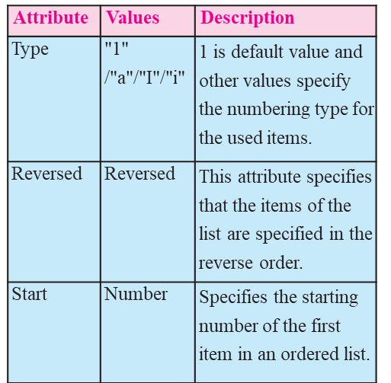

**Q5. Write short note on unordered list in HTML5**. Ans:- An unordered list created using the

<ul> tag, and each list item starts with the <li> tag. The list items in unordered lists are marked with bullets (small black circles), by default.

